Synchronous Buck Converter
Parameters –
Battery voltage – 24v
Ripple inductor current – 10%
Ripple Capacitance voltage – 2%
Switching frequency – 250 khz
Duty cycle – 40%
--- power – 10w

Calculated –
Vout – 9.6v
Iout – 1.042A
Load resistance – 9.21ohms
Inductance Ripple current – 0.1042A
Capacitance ripple voltage – 0.192v
Inductance – 2.21uH
Capacitance – 271.35uF

T = 4us
Ton – 1.6us (40% duty cycle)
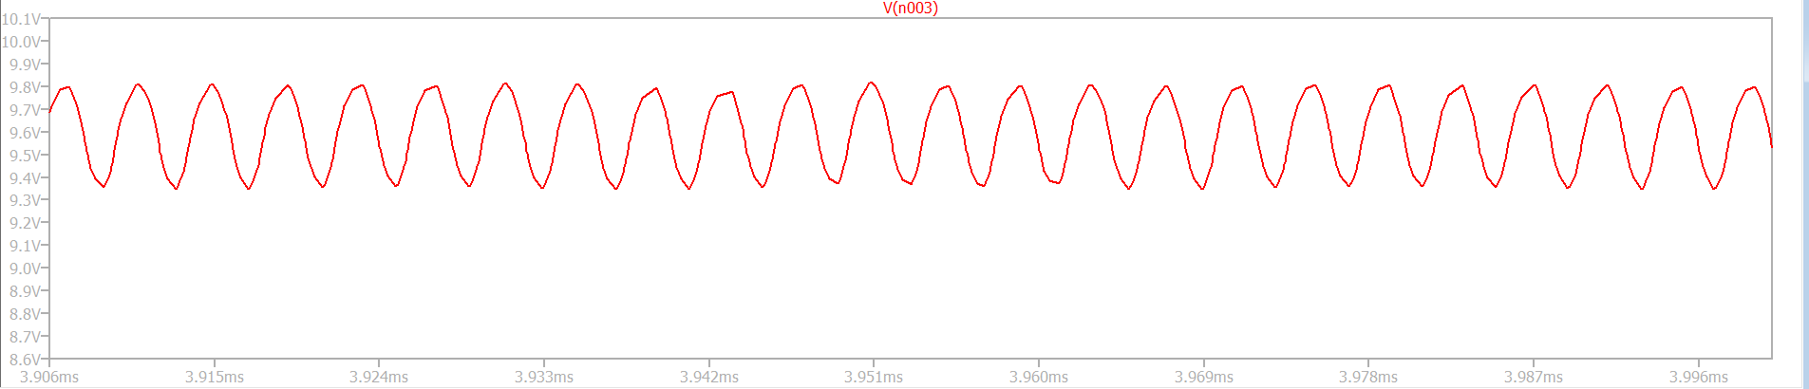
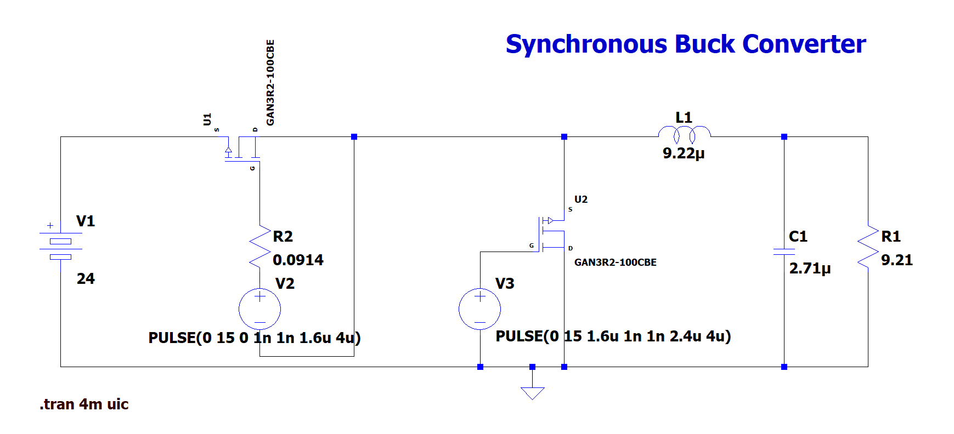

Output voltage

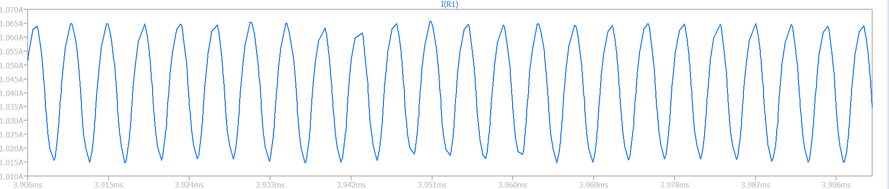
Output current
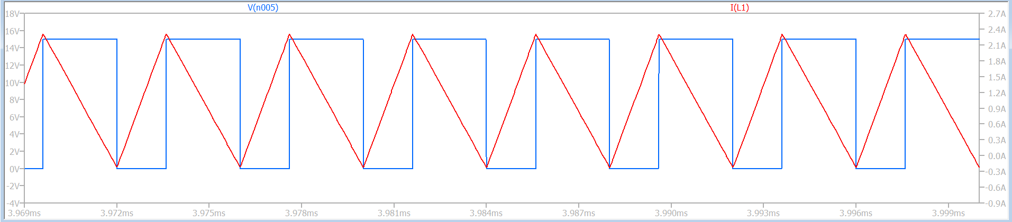
Inductor output current, Voltage pulse -1
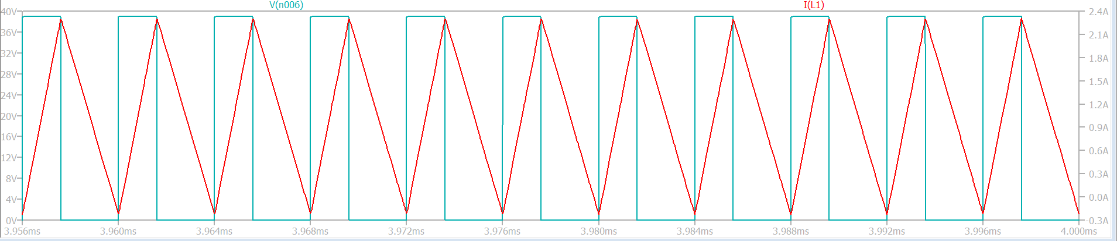
Inductor output current, Voltage pulse -2
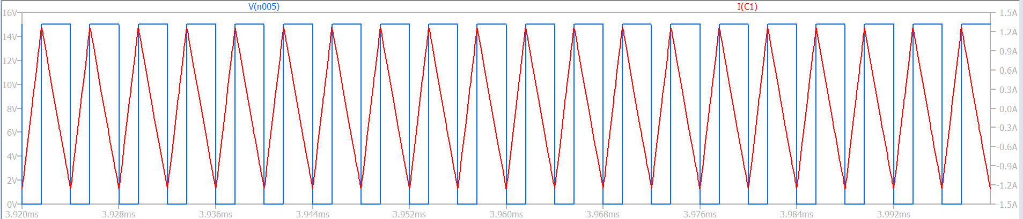
Capacitance output voltage, Voltage P luse.

